

HOME SHOPPE
Analysis Design Document

Group : No.3

Group members :
- Đặng Anh Tâm
- Đặng Anh Thịnh
- Nguyễn Đức Ngọc
- Lê Nguyễn Hùng Tuấn

Instructor : nguyen phuc vuong

Class : ACCP1408A

Date: 05 – 07 -2016

This is to certify that
Mr. / Ms.:

Has successfully designed, developed and hosted
HOME SHOPPE

Submitted by:
Mr.Trưnguyen phuc vuong
(Faculty Guilde’s Name and Signature)

Category
Content Page
1/ General introduction
1.1/ Website introduction 4
1.2/ Website functions 4
1.3/ System Requirment Specification 5

2/ Diagram – Database design
2.1/ Use Case 6
2.1.1/ Actors – Features – Function 6 - 8
2.1.2/ Use Case diagram 9 - 11
2.2/ Workflow diagram 12 - 14
2.3/ Dataflow diagram 15
2.4/ Entity Relationship Diagram(ERD) 16 – 19
2.5/ Database diagram 20
2.6/ Database table design 21 – 24

3/ Layouts design
3.1/ Home page 25
3.2/ View product 25
3.3/ Search 26
3.4/ Register 26
3.5/ Login 27
3.6/ Forget password 27
3.7/ Add to cart 28
3.8/ Admin page 28
3.9/ Create product 29
3.10/ Edit product 29
3.11/ Delete product 30

4/ Members task 31

1/ General Introduction:

1.1/ Website Introduction

-Nowaday, the demand of customer are so high. Customer want to buy many kind of product such as: smartphone, table, laptop, accessories, clothes, shoes, food, drink... They want to shopping everthing at their home with the favorable service as delivery, discount, gift…

-For this reason, our group start to build a website HOME SHOPPE . HOME SHOPPE have all product that customer demand. We have a website with a excellent service. Website make the customer feeling relax when they use our website

1.2/ Website Functions

- Admin:
- Login to edit all features on website.
- Manage product’s cart, payment online.
- Have authority to Insert – Delete – Update products and users.
- View customer’s feedback and reply by email.
- Check Order’s status.
- Client:
- Login in website.
- Search and view all product’s infomations.
- Add - Delete products from cart.
- Make orders.Give feedback for admin.
- View bonus points.
- Payment by credit card, cash.

1.3/ System Requirment Specification

1.3.1/ Server Side

- Hardware:
A Pentium 4 - 3.0 GHz or higher.
2GB of ram or higher.
HDD 5G available.

- Software:
OS: Windows XP, Windows 7/8/10.
DBMS: SQL Server 2012 or higher.

- Development software:
Visual Studio 2013 or higher.
SQL Server 2012 or higher.

- Technology:
Microsoft SDK 7 or higher.

1.3.2/ Client Side

- Hardware:
A Pentium 4 - 3.0 GHz or higher.
2GB of ram or higher.
HDD 5G available.

- Software:
OS: Windows XP, Windows 7/8/10.
Visual Studio 2013 or higher
2/ Diagram – Database design:
2.1/ Use Case
2.1.1/ Actor – Features - Functions
- Actor

Actor Name | Description
Customer | - Register  - View and Search products in the website  - View points and money  - View Related Products
User | - Login  - Edit User's profile  - View and Search products in the website  - Registration of orders  - Payment online  - View Related Products
Admin | - Login  - Manage and View All user's profile details  - Product Management  - Order Management Users  - Receive payment offline and change status  - Email inform to customers  - Update website
- Features

Use Case | Use-Case  Order | Description
Account
Resgister | UseCase_1 | Customer registers for an account to perform further tasks
Login | UseCase_2 | User or Admin logins to perform corresponding tasks
Logout | UseCase_3 | User or Admin logouts to terminate their accessibility
Edit Profile | UseCase_4 | User or Admin changes account information
Customer and User
Manage Customer | UseCase_5 | Admin views all Customer account
Manage User | UseCase_6 | Admin views all User account
Products
Manage Product | UseCase_7 | View all products including some links to do further tasks
View Product | UseCase_8 | View all product information
Search Product | UseCase_9 | Search for specific product
Insert Product | UseCase_10 | Insert new product
Delete Product | UseCase_11 | Delete a product
Update Product | UseCase_12 | Update a product‘s detail
- Functions

Use Case | Customer | User | Admin
Account
UseCase_1 | Y
UseCase_2 |  | Y | Y
UseCase_3 |  | Y | Y
UseCase_4 |  | Y | Y
Customer and User
UseCase_5 |  |  | Y
UseCase_6 |  |  | Y
Products
UseCase_7 |  |  | Y
UseCase_8 | Y | Y | Y
UseCase_9 | Y | Y | Y
UseCase_10 |  |  | Y
UseCase_11 |  |  | Y
UseCase_12 |  |  | Y

2.1.2/ Use Case Diagram
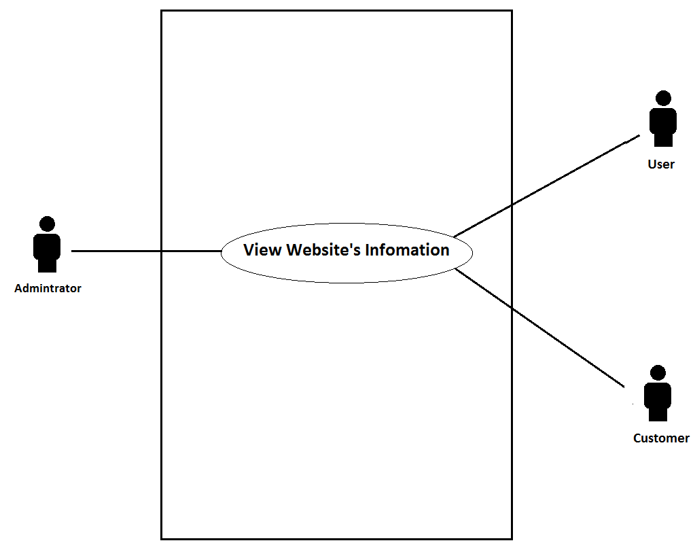
- Admin/User/Customer view Website’s Information

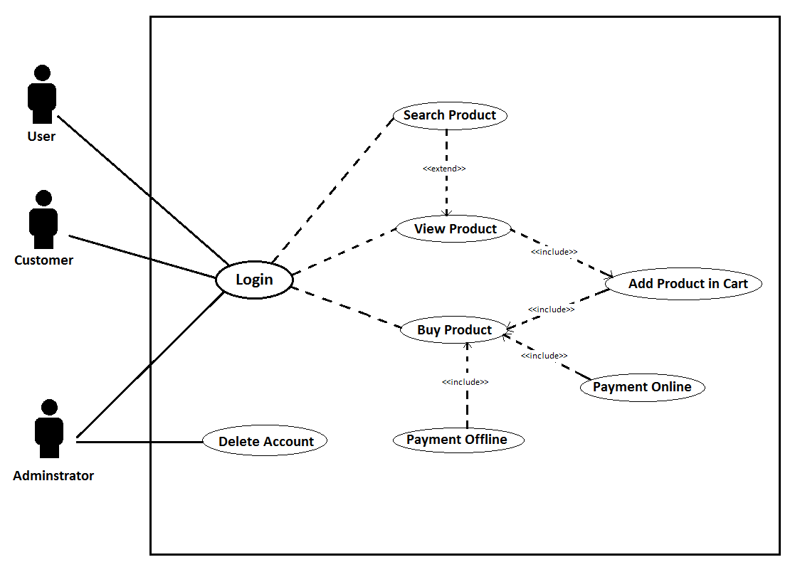
- Login
- Admin manage User’s Profile
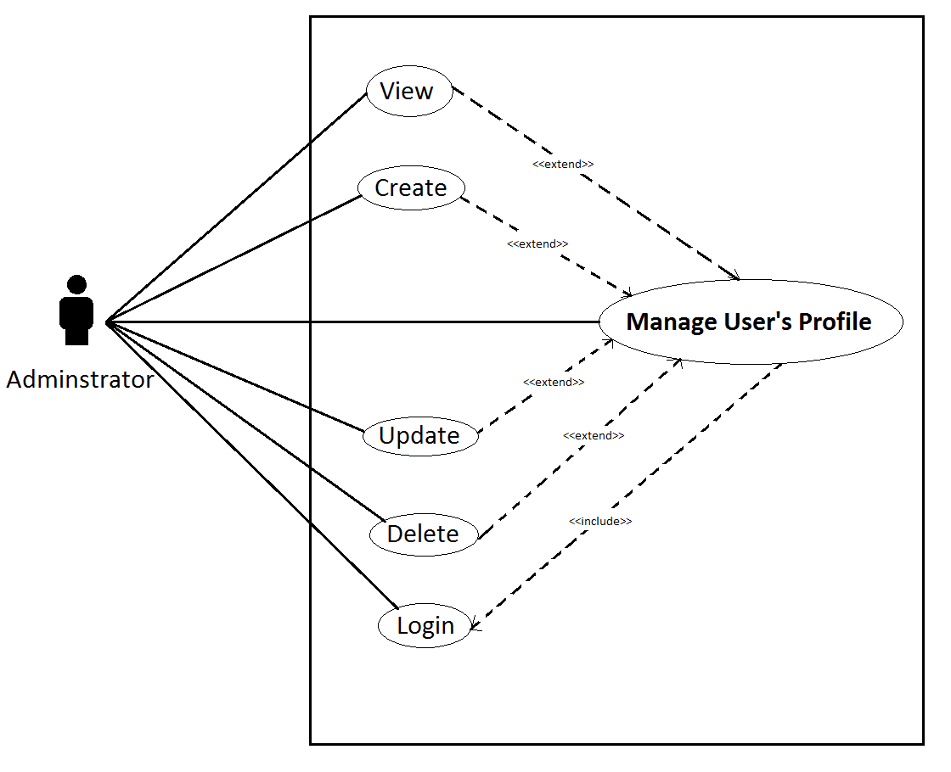

2.2/ Workflow Diagram
- Create a new product
-Object using: Adminstrator
-Function: To create a new product on website
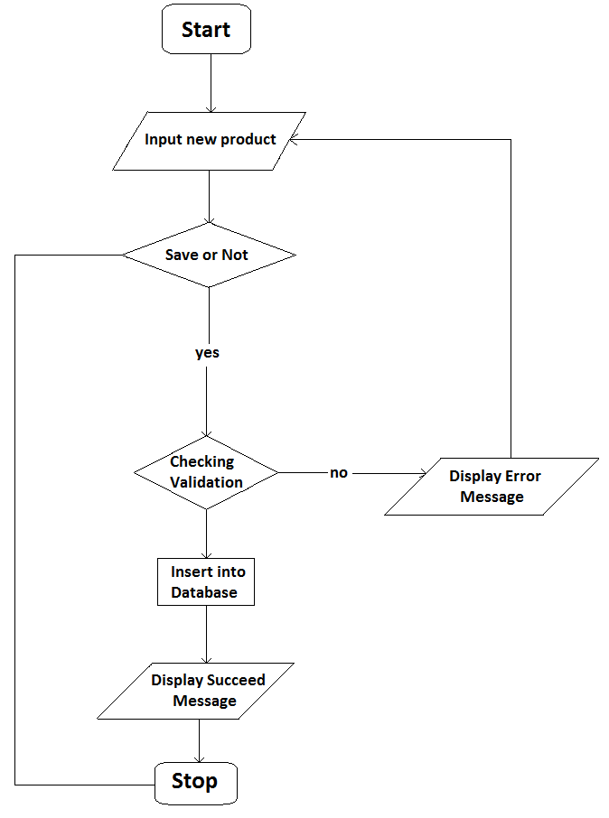
- Delete a product
-Object using: Adminstrator
-Function: To delete a new product on website
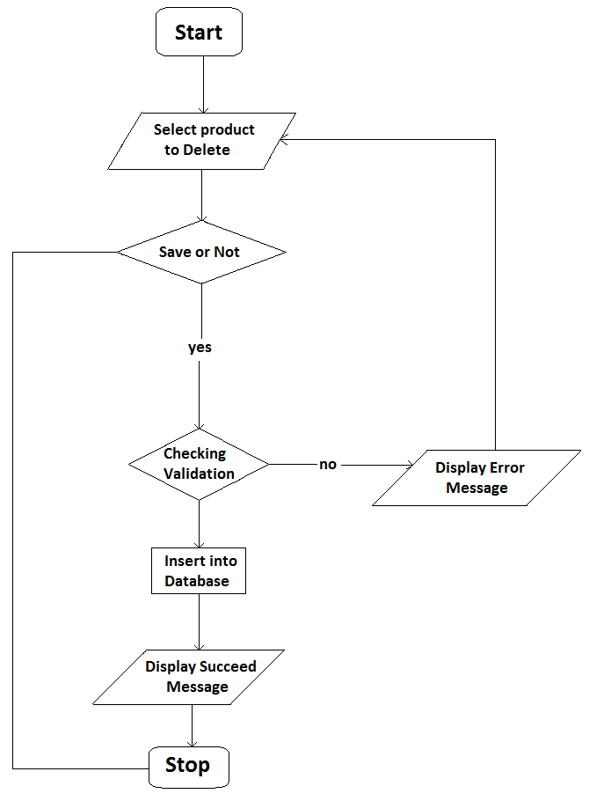

- Edit a product
-Object using: Adminstrator
-Function: To edit a new product on website
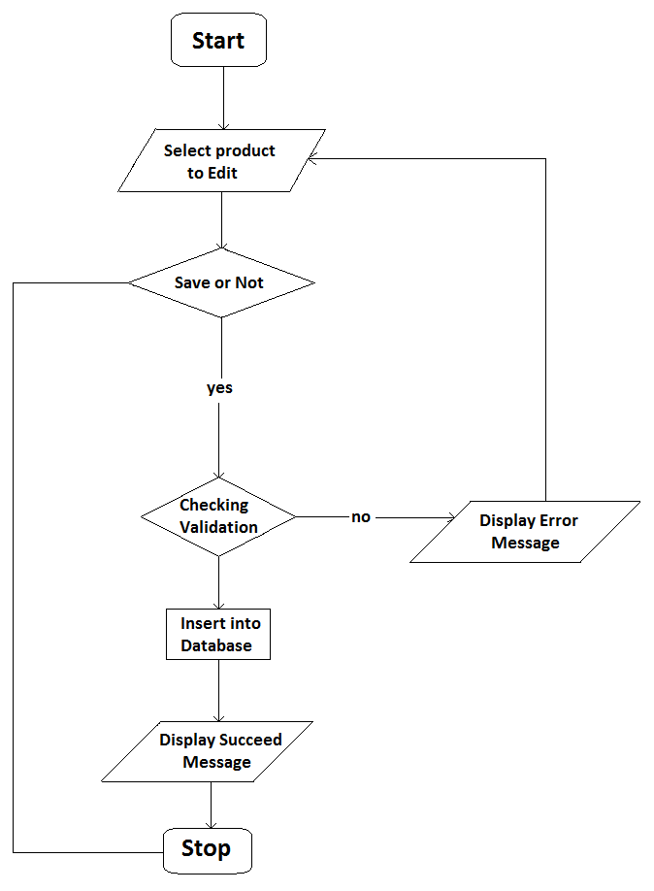

2.3/ Dataflow Diagram
- Adminstrator manage product
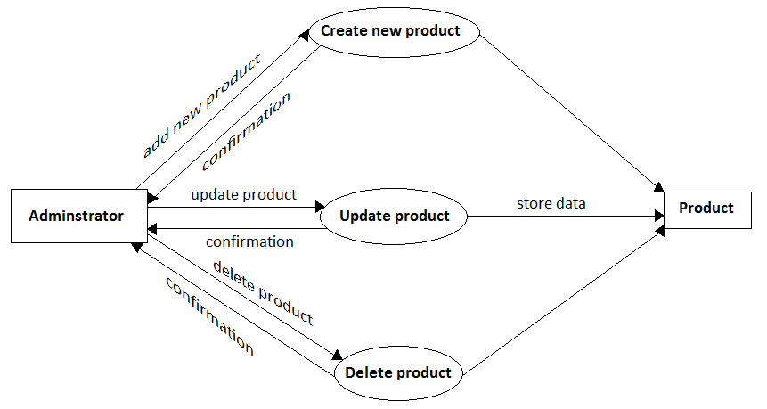
- Customer add product to cart and create an order
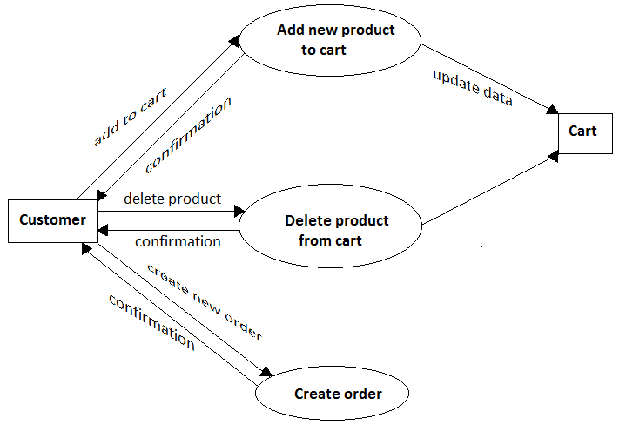

T

2.4/ Entity Relationship Diagram (ERD)
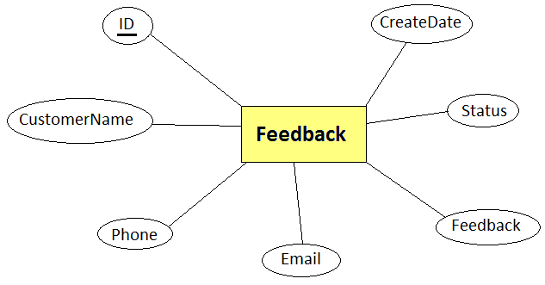
- Feedback

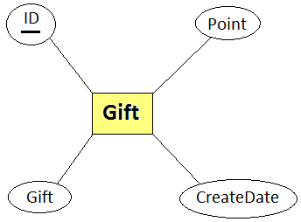
- Gift

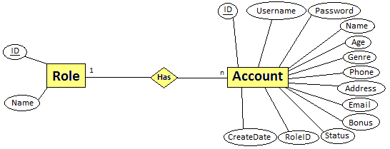
- Role – Account

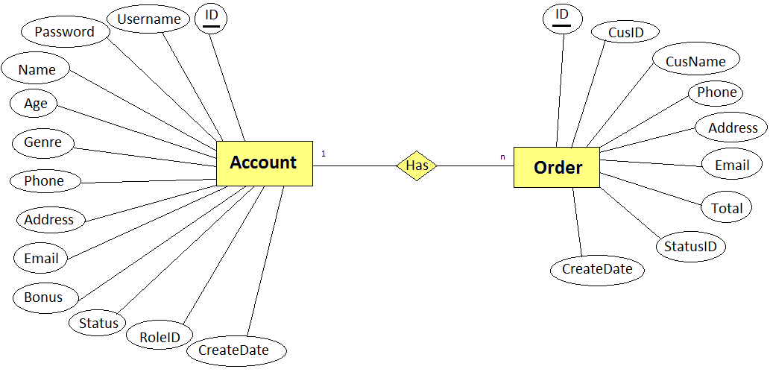
- Account – Order
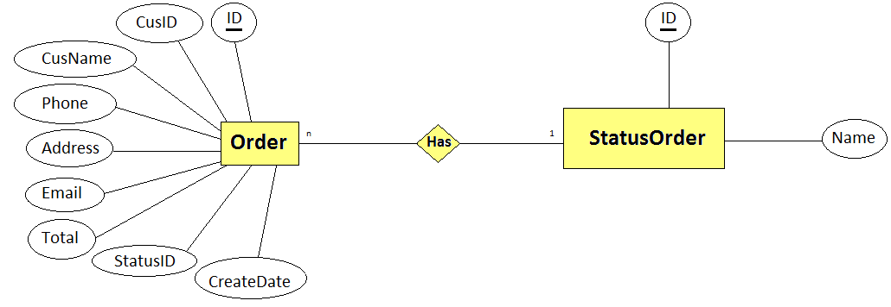
- StatusOrder – Order

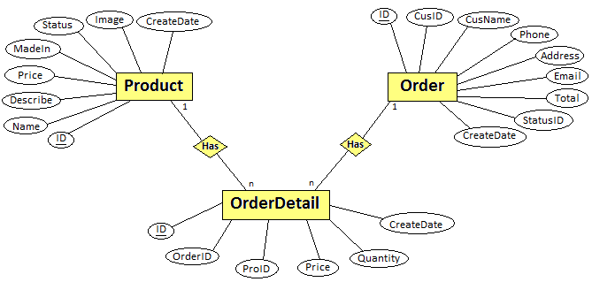
- Order - OrderDetail – Product

- Product - Pro_ProType – ProductType

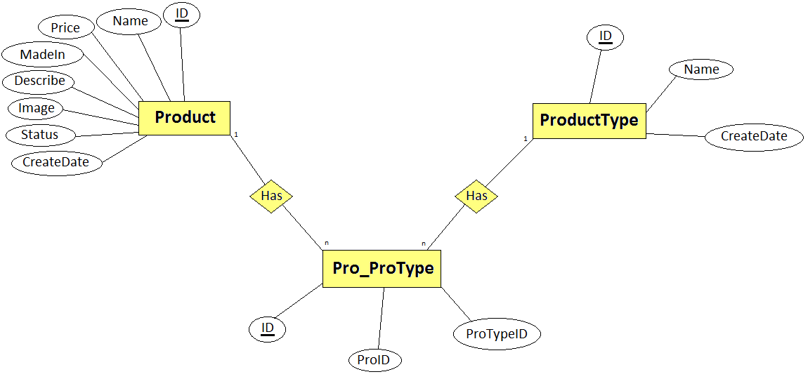

2.5/ Database diagram
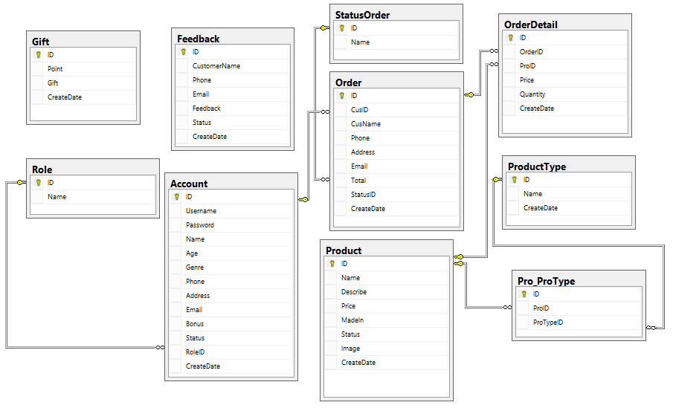

2.6/ Database table design

FEEDBACK
Column Name | Data Type | Allow Nulls
ID | int
CustomerName | nvarchar(50) | ✓
Phone | nvarchar(50) | ✓
Email | nvarchar(50) | ✓
Feedback | nvarchar(MAX)
Status | bit | ✓
CreateDate | datetime | ✓

GIFT
Column Name | Data Type | Allow Nulls
ID | int
Point | nvarchar(50) | ✓
Gift | nvarchar(50) | ✓
CreateDate | datetime | ✓

ORDER DETAIL
Column Name | Data Type | Allow Nulls
ID | int
OrderID | int
ProID | int
Price | float | ✓
Quantity | int | ✓
CreateDate | datetime | ✓

ORDER
Column Name | Data Type | Allow Nulls
ID | int
CusID | int
CusName | nvarchar(50)
Phone | nvarchar(50)
Address | nvarchar(100)
Email | nvarchar(50) | ✓
Total | float | ✓
StatusID | int | ✓
CreateDate | datetime | ✓

ACCOUNT
Column Name | Data Type | Allow Nulls
ID | int
Username | nvarchar(100)
Password | nvarchar(100)
Name | nvarchar(100) | ✓
Age | int | ✓
Genre | nvarchar(50) | ✓
Phone | int
Address | nvarchar(150) | ✓
Email | nvarchar(50)
Bonus | int | ✓
Status | int | ✓
RoleID | int | ✓
CreateDate | datetime | ✓

PRO_PRO TYPE
Column Name | Data Type | Allow Nulls
ID | int
ProID | int
ProTypeID | int

PRODUCT
Column Name | Data Type | Allow Nulls
ID | int
Name | nvarchar(100) | ✓
Describe | nvarchar(MAX) | ✓
Price | float | ✓
MadeIn | nvarchar(50) | ✓
Status | bit | ✓
Image | nvarchar(100) | ✓
CreateDate | datetime | ✓

PRODUCT TYPE
Column Name | Data Type | Allow Nulls
ID | int
Name | nvarchar(50)
CreateDate | datetime | ✓

ROLE
Column Name | Data Type | Allow Nulls
ID | int
Name | nvarchar(50) | ✓

STATUS ORDER
Column Name | Data Type | Allow Nulls
ID | int
Name | nvarchar(50) | ✓

3/ Layouts design
3.1/ Home page
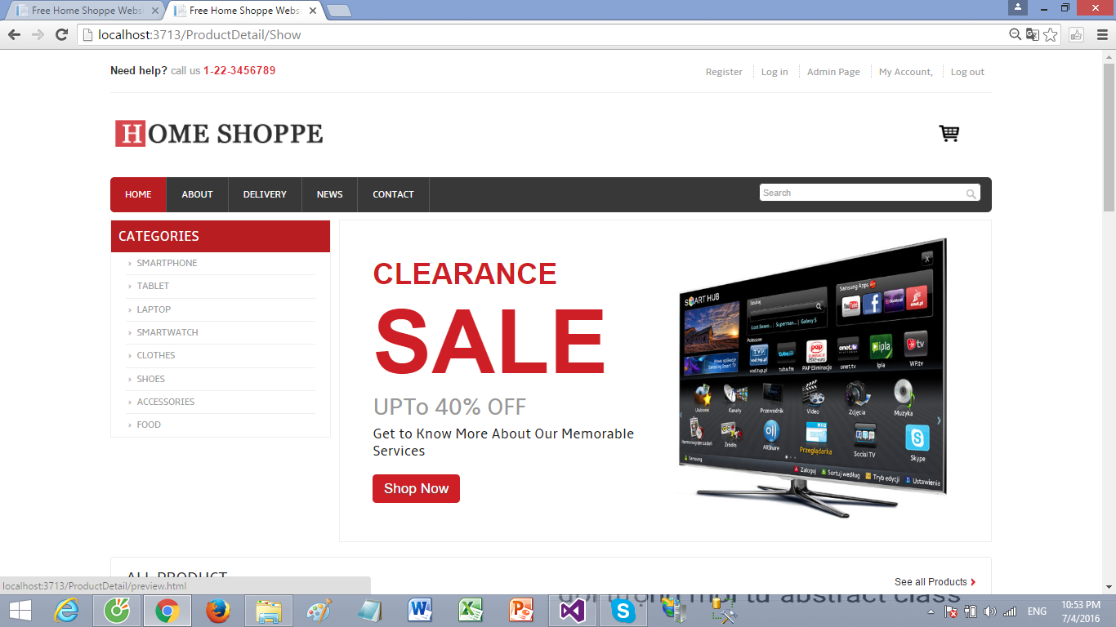
3.2/ View product
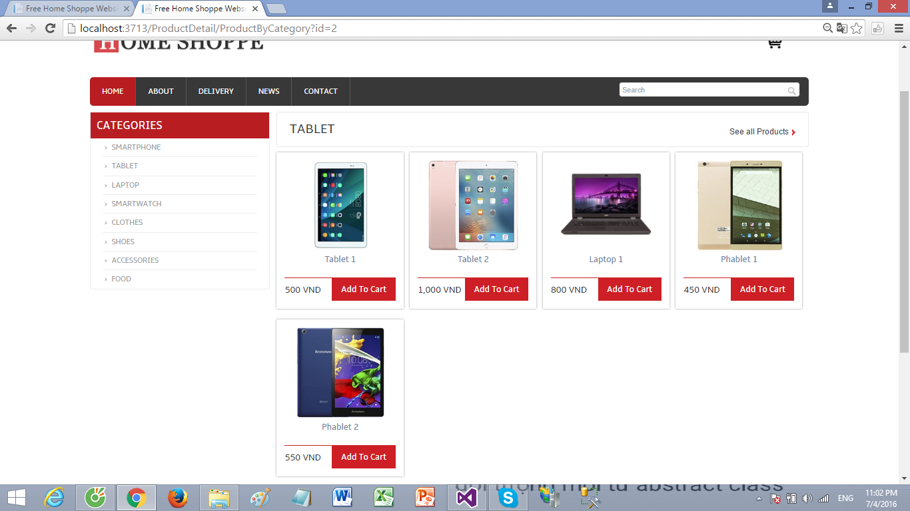
3.3/ Search
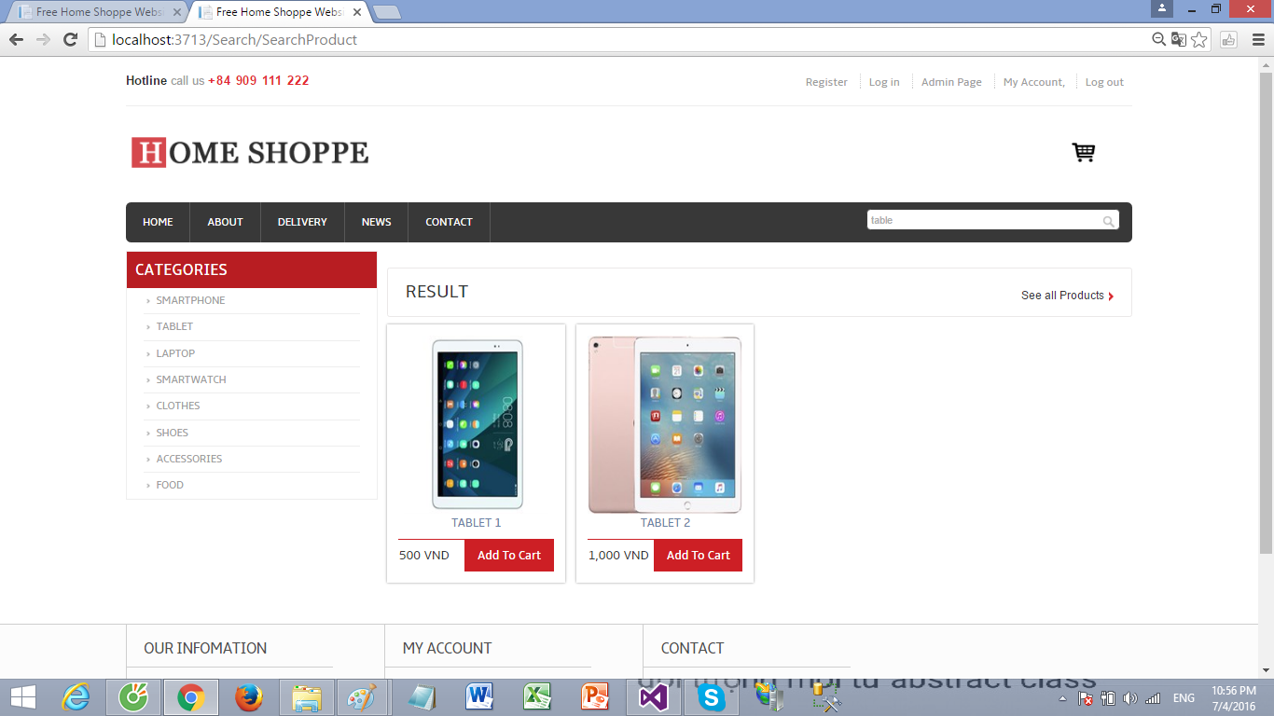
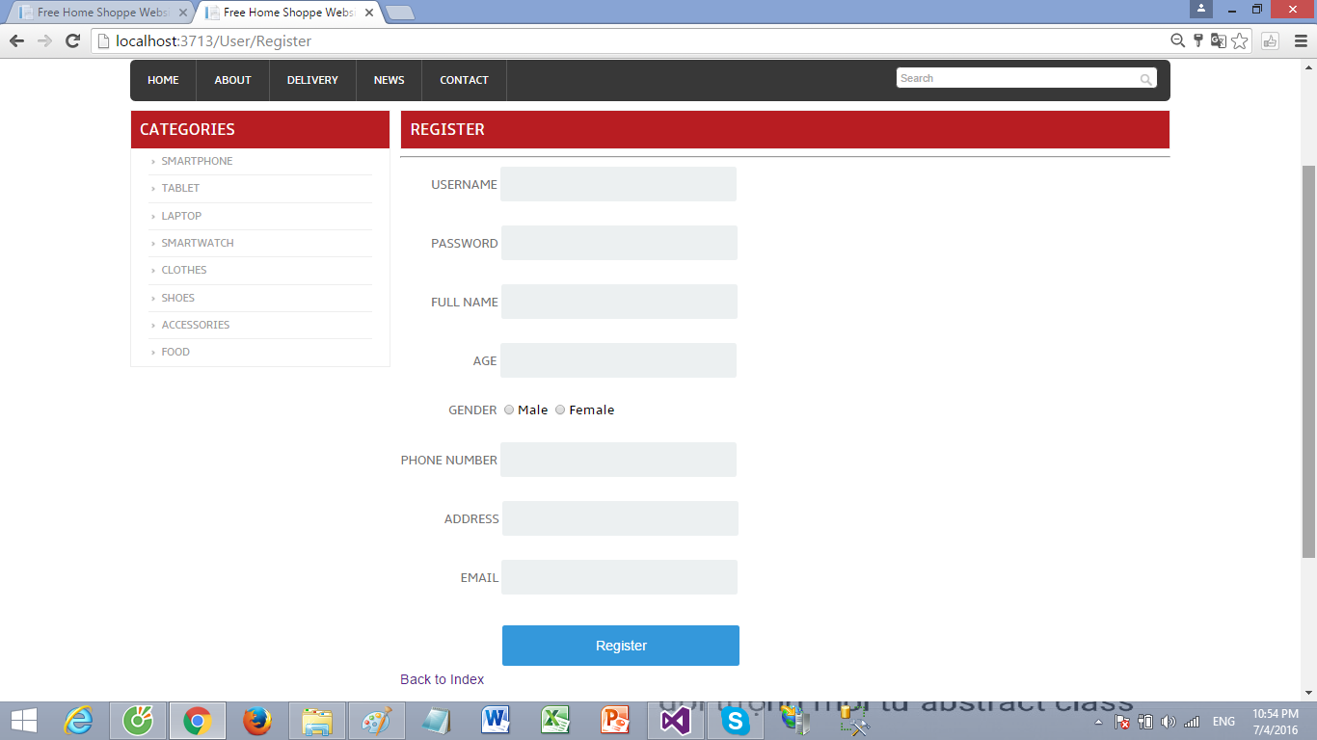
3.4/ Register
3.5/ Login
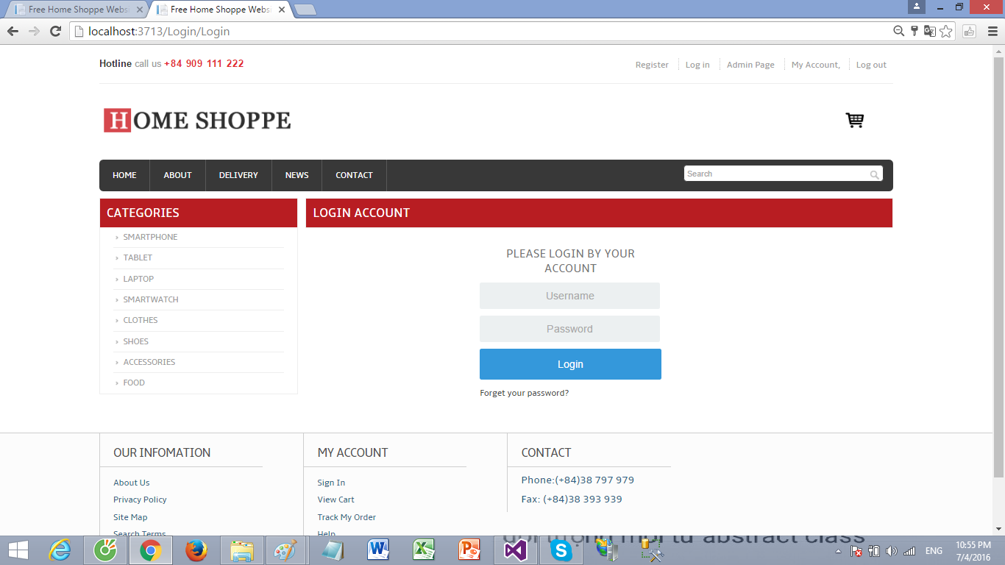
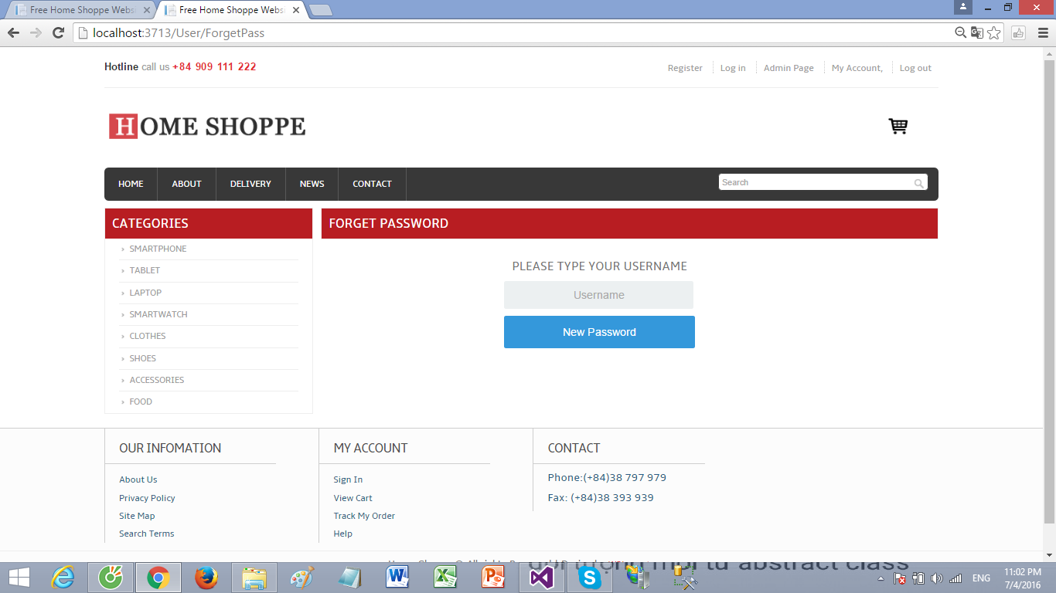
3.6/ Forget password
3.7/ Add to cart
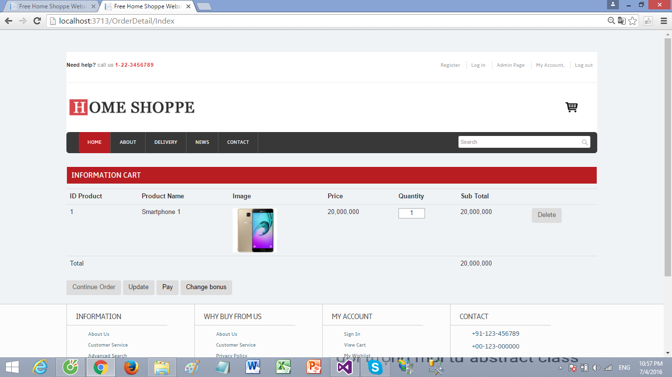
3.8/ Admin page
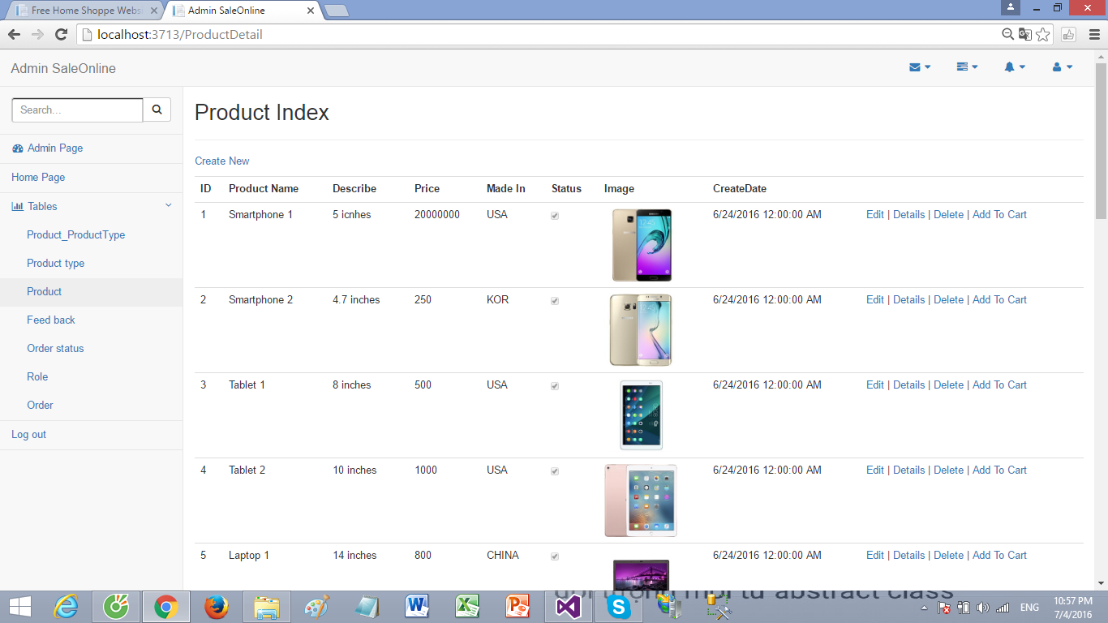
3.9/ Create product
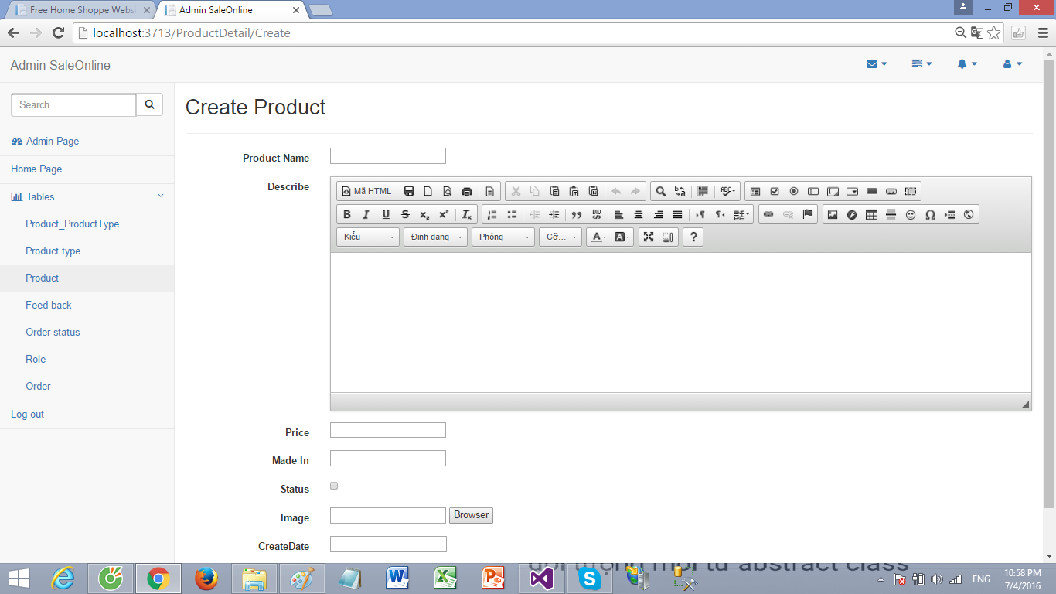
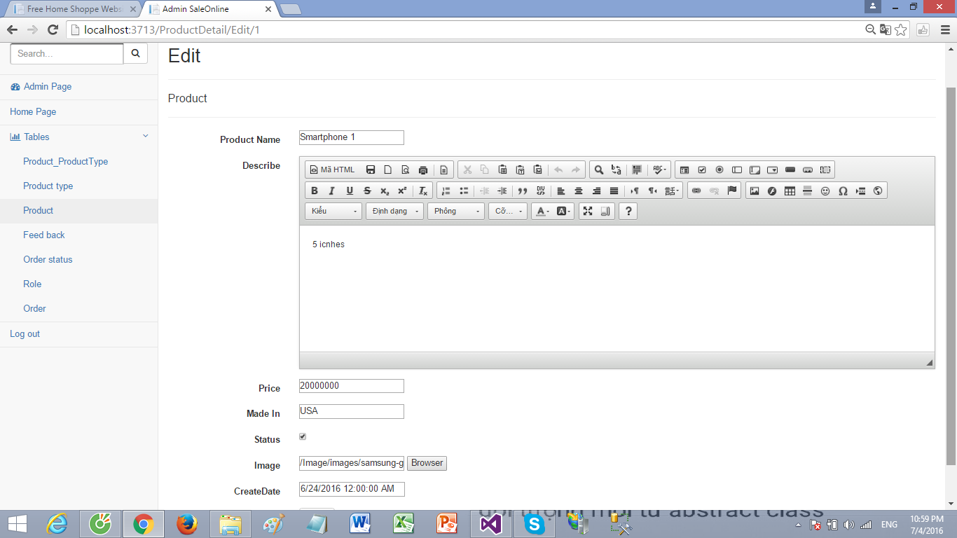
3.10/ Edit product

3.11/ Delete product
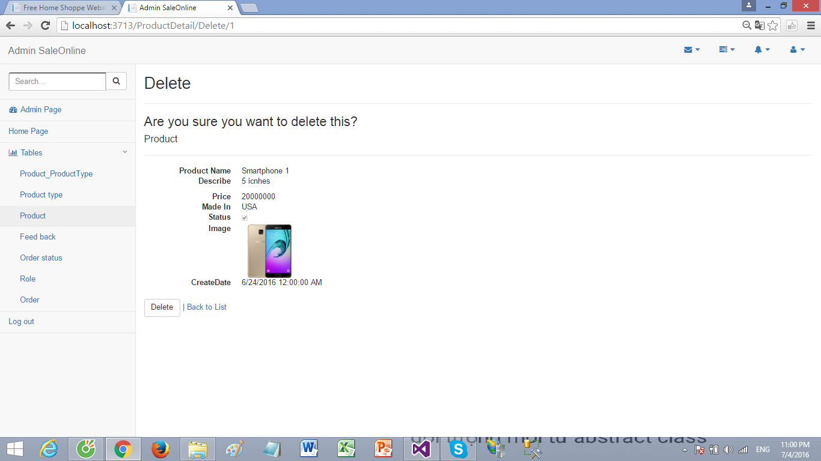

4/ Members task

Task Describe | Start | Deadline | Member | Status
-Send mail  -Forget password  -Validate  -Design user layout  -Document  -Database | 28-05-2016 | 02-07-2016 | Đặng Anh Thịnh | Done
-Logout/payment/change password  -Admin function  -Search  -Document  -Database | 28-05-2016 | 02-07-2016 | Đặng Anh Tâm | Done
-User layouts  -Add to cart  -View product  -Document  -Database  -Upload file | 28-05-2016 | 02-07-2016 | Lê Nguyễn Hùng Tuấn | Done
-Login  -Register  -Design user page  -Document  -Database | 28-05-2016 | 02-07-2016 | Nguyễn Đức Ngọc | Done

